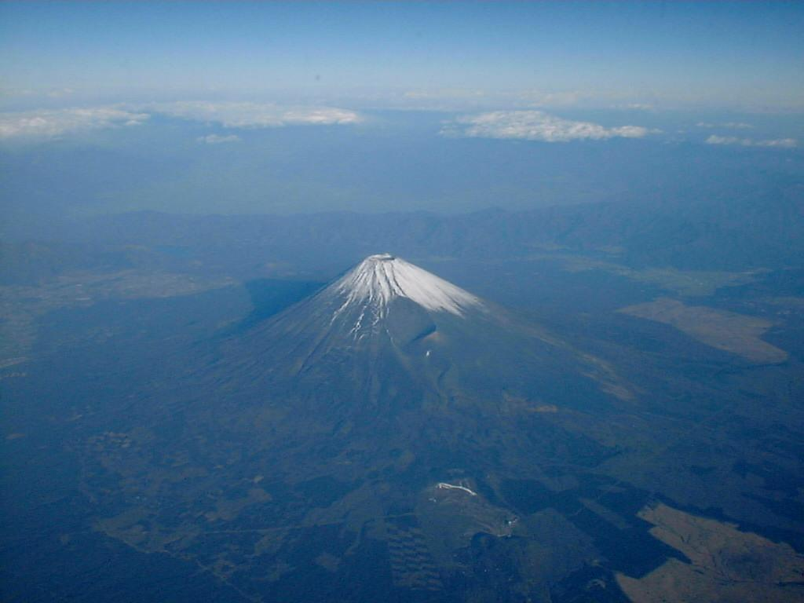

Date: March 20th 2005 (Sun)
Assembly area: Fuji-city Shonen shizen no Ie (youth outdoor centre)
10847‐1 Obuchi, Fuji-city, Shizuoka

Map: 1:10 000 5 m contours

Organizer: Japan Orienteering Association
Shizuoka Orienteering Association
Technical Director: Rob PLOWRIGHT
Course planner: Rob PLOWRIGHT
Controller: WAKAUME Tomoyuki

Web: http://www.orienteering.com/~joc2004/index.html

- Location Map
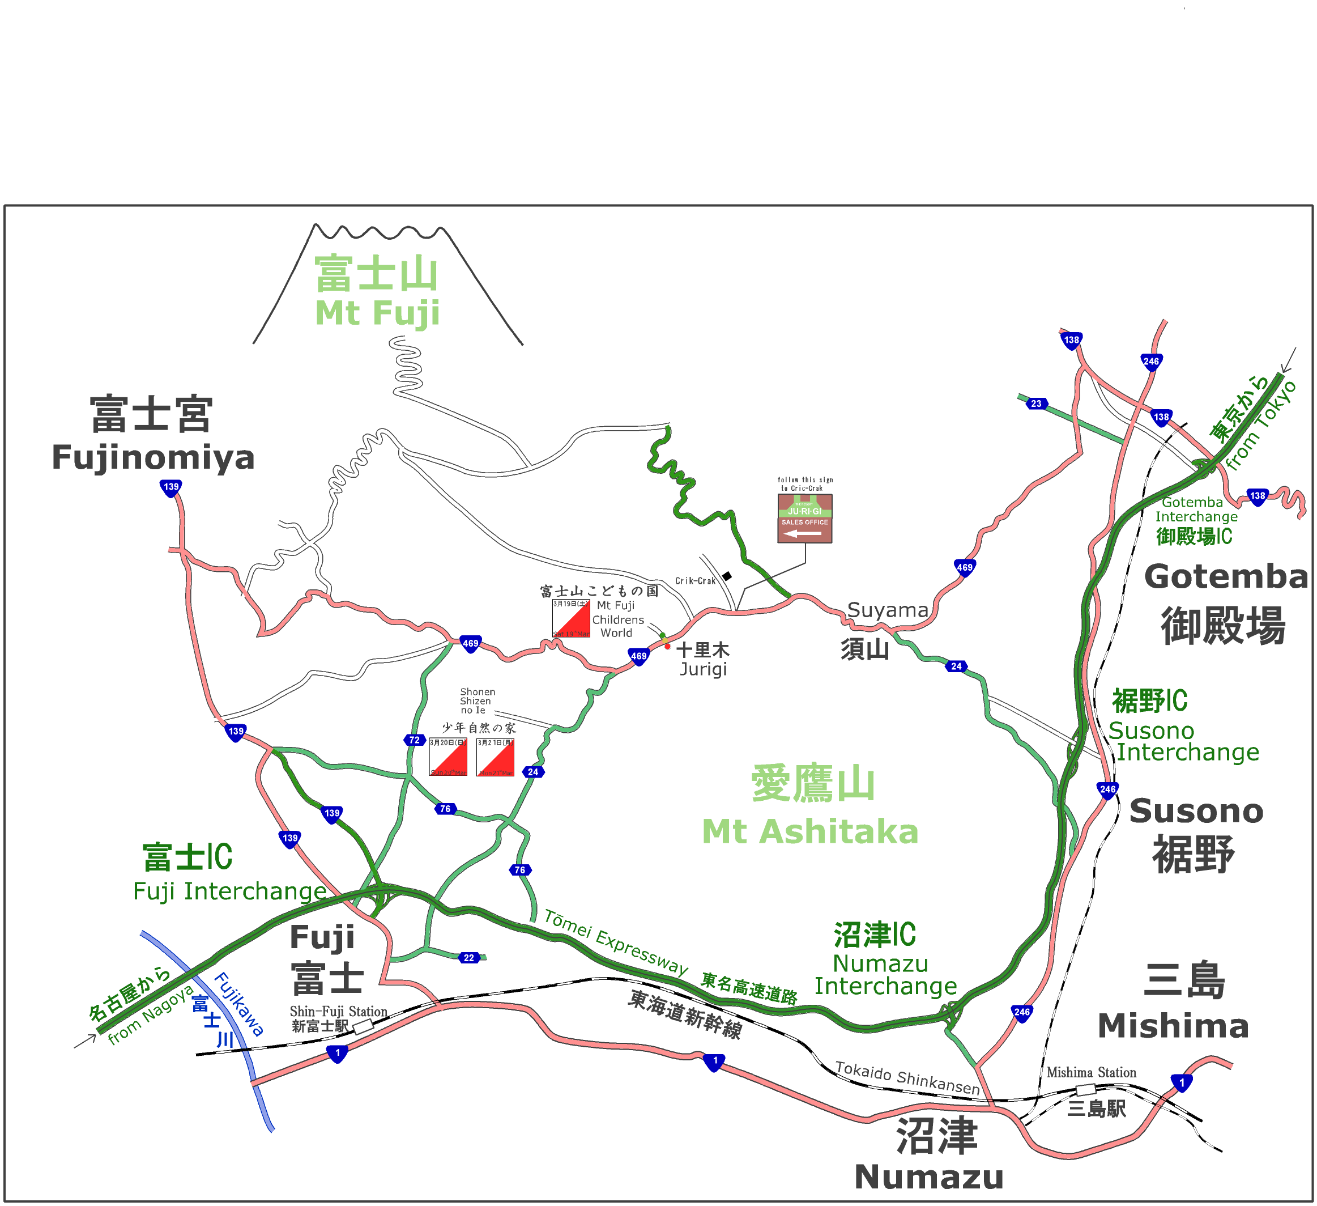

●Access/Transportations
【Event Centre】 Fuji-city Shonen Shizen no Ie (youth outdoor centre)
10847-1 Obuchi, Fuji-city, Shizuoka
Ｔｅｌ： 0545-35-1697

【Registration open】 8:30～10:30

【By Car】
40 min. drive from Tomei Expressway Fuji Interchange. Take Route 24 or Route72 and 469 to Mt Fuji Children’s World.
50 min. drive from Tomei Expressway Susono Interchange. Take Route 24 and 469 to Mt Fuji Children’s World.

Parking Information
All parking for the Japan Championships will be Mt. Fuji Children’s World. There will be a shuttle bus to the assembly area. It will take about 15-20 min. from Mt.Fuji Children’s World to the assembly area. （\500円 return.. Please pay at the parking.）
Please keep the ticket for the return ride.
We will allocate the cars in case there are too many participants.
NOTE: There are some parking areas close to the assembly area, but they are reserved for use by the general public. Japan Championships competitors may not use them. There will be a drop off zone close to the event centre where people and luggage can be off loaded before proceeding to the parking at Mt Fuji Children’s World.
Parking lot is available during ８：00～17：00.

Shuttle bus
8：00～11：00 (Every 15～20minutes) From Mt Fuji Children’s World
13：00～16：00 (Every 15～20minutes) From Assembly area

- Parking lot map

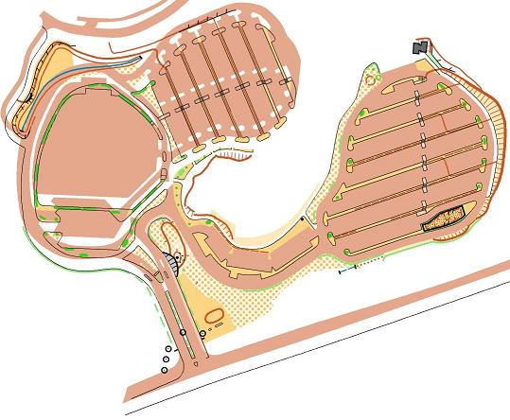
Mt Fuji Children’s World
Parking lot
The area marked as ×is the parking lot for general public. You may not use it. (It is available on 19th)

Parking lot for the event

Shuttle bus stop

Route 469
From Gotemba / Susono
From Fuji / Assembly area

Mt Fuji Children’s World traffic lights

◎Assembly Area
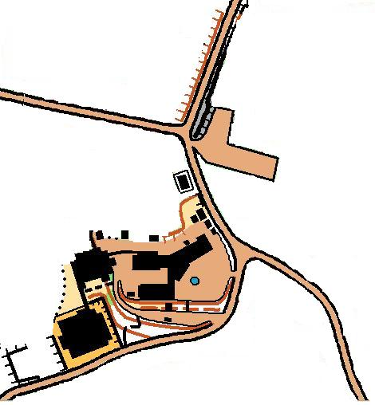

・Event Bus Bus Stop / drop off zone (From Fuji stn, Shin-Fuji stn, and Mt Fuji Children’s world

・Car drop off zone(Buses have priority )

Assemby Area
(Shonen Shizen no Ie)
）

・Bus and cars (From Route 24)

Please come from this direction.

◎ Layout of the Assembly Area
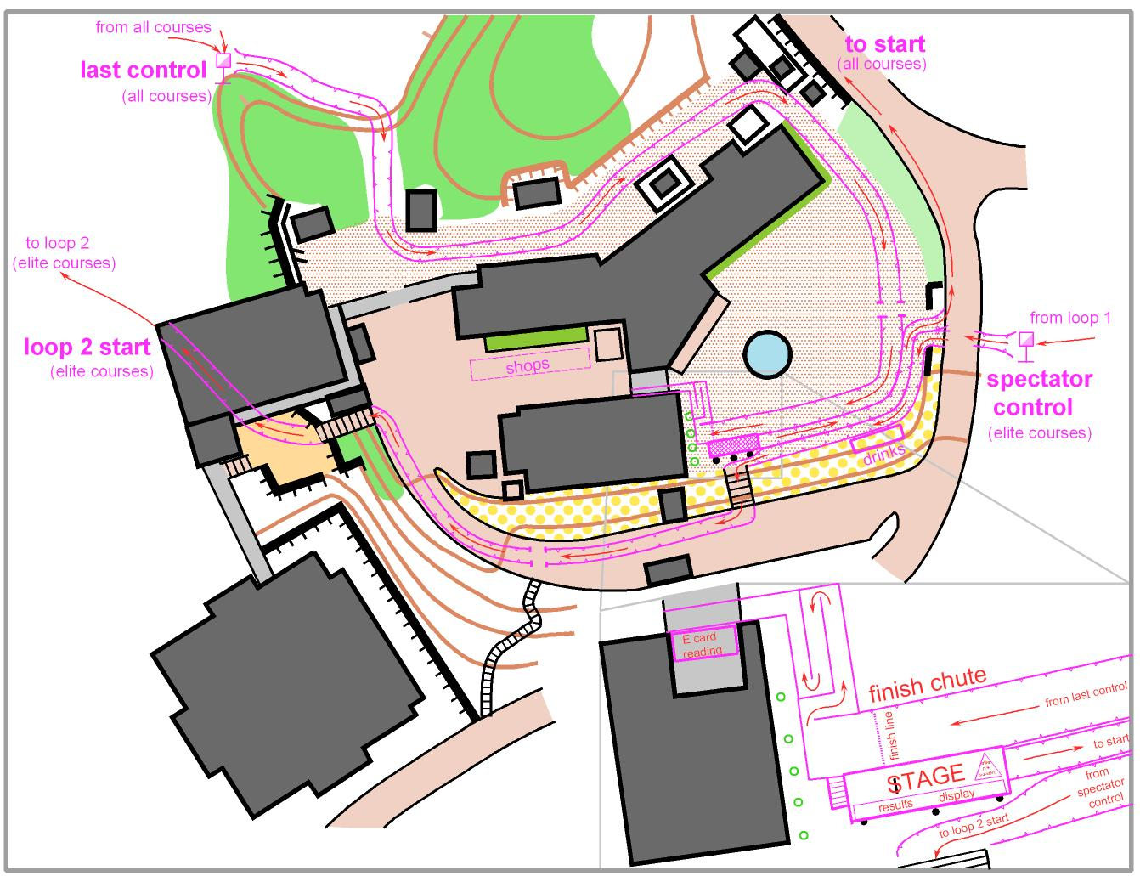

◎Shonen Shizen no Ie building plan

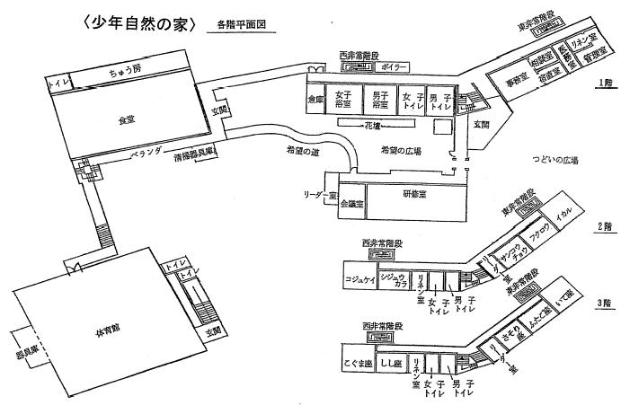
速報所
計セン
Women’s Change room
Event office
Reception
Gym
Men’s Change room
Entrance of the building
(competitors)
Entrance of the gym
Number bibs, E-cards, and control discriptions

Entrance of the building
(competitors)
年自然の家本館への
参加者出入口
参加者通路
（利用可）
Kids’ room
2nd floor

3rd floor

Toilet
Toilet
Showers
Eating Space
1st floor
クディスタンス競技
・パンチングシステム：ｅｍｉｔ社製電子パンチを使用

・2004年静岡県OL協会作成
（1988年静岡県OL協会作成「不二丸尾」Remake）
・ISOM2000準拠
・Trimble社Differential GPS使用
・縮尺 1:10000 等高線間隔 5m 通行可能度4段階表示
・耐水ビニール封入済み 地図サイズ：Ａ３
・コントロール位置説明：IOF記号。ただしNクラスは日本語表記を用います。

※注意事項
・大会開催前のＯ－ｍａｐ「不二丸尾」「ふじ」「逆杉」区域へのオリエンテーリング目的での
立ち入りおよび会場への上記Ｏ－ｍａｐの地図の持ち込みを禁止します。
持ち込みが発覚した場合は失格となりますのでご注意ください。
・地図記号はISOM2000に準拠していますが以下のものはその限りではありません。
ほこら、石碑、その他の人工特徴物 | Ｘ (黒)

●Technical information
【First Starts】 9.30am
【Type】 Long distance
【Rules】 Japan Orienteering Association’s Competition Rules.
【Control descriptions】 ＩＯＦ symbols （Japanese will be used for Ｎclasses）
【Map】 1:10000, 5m contours, ISOM 2000, Offset printed
【Special symbols】
・Map symbols are shown by ISOM2000. However, there are following special symbols.
Small shrine, and other man made features | Ｘ (black)
Charcoal burning ground | ○ (black)
Mushroom logs OUT OF BOUNDS | Diagonal green cross hatch
Tea plantation OUT OF BOUNDS | Vertical green dashes on yellow background (ISOM symbol 413: Vineyard)

【Map size】
Ｍ２１Ｅ ３８０×３６０mm
Ｗ２１Ｅ、Ｍ２０Ｅ、Ｍ２１Ａ ３６４×２５７mm
Other classes Ａ４（２１０×１９７mm）

【Terrain description】
The competition terrain lies on the southern slopes of Mt Fuji between 500 and 650m. It is predominantly open cedar forest with a moderately dense network of roads, forestry tracks, and walking paths. Some parts of the terrain have extensive areas of reduced runnability. Contour detail varies from moderate to very detailed and parts of the terrain are crisscrossed by complex networks of watercourses (usually dry) and occasional steep sided ravines. The terrain is also traversed by a lava flow from the last eruption of Mt Fuji (1707). These areas are extremely rocky underfoot and covered in dense deciduous forest.
【Punching】 Emit
【Ｓｔａｒｔ】 Ｌｉｆｔ ｕｐ ｓｔａｒｔ
【Ｆｉｎｉｓｈ】 Punching finish
【Ruled time】 Elite class ：150％ of the winning time Ａ class： 200％ of the winning time
【Training map】 We will offer the map ‘Sekotsuji（勢子辻）’ for training on19th. It’s about 15 minutes drive from the event area.

○ We will not collect maps. Please do not show your map to the runners who haven’t started.

- There are out of bounds areas marked with blue and yellow tapes which are not shown on the map. Please do not enter these areas.

○ Courses
Class | Length(m) | Up(m) | Winning time  (minutes) | People | Class | Length(m) | Up(m) | Winning time  (minutes) | People
M21E | 12,340 | 550 | 90 | 64 | W21E | 7,450 | 375 | 75 | 38
M20E | 7,450 | 375 | 70 | 20 | W20E | 4,300 | 190 | 60 | 5
M70A | 2,870 | 125 | 50 | 40
M65A | 2,870 | 125 | 50 | 35 | W65A | 2,400 | 105 | 45 | 9
M60A | 3,410 | 150 | 50 | 50 | W60A | 2,400 | 105 | 45 | 7
M55A | 4,120 | 180 | 50 | 50 | W55A | 2,400 | 105 | 40 | 6
M50A | 4,860 | 210 | 60 | 38 | W50A | 2,400 | 105 | 40 | 6
M45A | 4,860 | 210 | 60 | 34 | W45A | 2,400 | 105 | 40 | 3
M40A | 5,410 | 240 | 65 | 52 | W40A | 2,870 | 125 | 50 | 7
M35A | 6,370 | 280 | 70 | 33 | W35A | 2,870 | 125 | 50 | 6
M21A1 | 8,640 | 390 | 80 | 78 | W21A | 4,860 | 210 | 65 | 60
M21A2 | 8,640 | 390 | 80 | 77
M21AS | 5,410 | 240 | 60 | 62 | W21AS | 2,870 | 125 | 50 | 14
M20A | 5,450 | 240 | 70 | 29 | W20A | 3,230 | 145 | 60 | 11
M18A | 4,430 | 195 | 60 | 15 | W18A | 2,460 | 110 | 50 | 1
M16A | 3,230 | 145 | 50 | 23 | W16A | 2,460 | 110 | 50 | 0
M14 | 2,250 | 70 | 50 | 2 | W14 | 2,250 | 70 | 40 | 2
M12 | 1,970 | 60 | 40 | 6 | W12 | 1,970 | 60 | 40 | 2
M10 | 1,970 | 60 | 40 | 2 | W10 | 1,970 | 60 | 40 | 2
MBL | 4,430 | 195 | 50 | 17 | WBL | 3,190 | 140 | 45 | 7
MBM | 3,190 | 140 | 50 | 41 | WBS | 2,460 | 110 | 45 | 7
MBS | 2,460 | 110 | 50 | 6
MN | 2,250 | 70 | 40 | 17 | WN | 2,250 | 70 | 40 | 6
OAL | 5,410 | 240 | 60 |  | OB | 3,190 | 140 | 50
OAM | 4,120 | 180 | 50 |  | ON | 2,250 | 70 | 40
OAS | 3,410 | 150 | 40

○Tape colors and estimated time
 | Tape color | minutes
Mt. Fuji Children’s World Parking lot ～ Assembly Area (By Bus) | ― | ２０
Assembly Area ～ Start Area（long distance） | Blue and White | １０
Start Area ～ Start control flag | Red and White | ―
Last control ～ Finish | Red and White | ―

●Time Schedule
Event Centre | ８：００～１６：３０
Parking lot | ８：００～１７：００
Start area | ９：３０～１３：００
Finish closing | １５：３０
Prize giving ceremony | １２：００～１５：３０
Selling Maps | １３：３０～

●Entry Fees
【Entry Fees】
Classes | Entry Fee
Elite | \4,500 | ・No printed program  －\200  ・No E-card rent  －\300  (Up to \500 discount)
A Class | \4,000
B Class  A Class (Under 18 years old) | \3,000
B Class (Under 18 years old) | \2,500
N class | \2,000
※ Entry fees will not be refunded for any reason.

【Payment】
Please pay the entry fee (cash only- Japanese Yen) on the event day at the reception desk.

- Inquiries
Should be directed to: Ms Masumi TOMITA
E-mail： masumi@tokai.or.jp
Ｆａｘ： +91 55-973-7021

3 Days of Orienteering
The championships form part of three days of orienteering. The following events are also being held:
March 19th（Sat）: Park Orienteering at Mt. Fuji Children’s World (map scale 1:5000)
Ａｂｏｕｔ ２．５ｋｍ
【Reｇistration Open】 ９：００－１４：００
【Punching】 Emit
【Entry Fee】 FＲＥＥ （However, you need to pay the entrance fee to enter the
Mt Fuji Children’s World; \800 each）

March 21st（Mon）: Sprint Relay (map scale 1:4000) using the same event centre as the Japan Championships.
２．５ｋｍ × ３people
【Start time】 10:00 (planned)
【Entry Fee】 \500 per person
【Dead line】 March 15th

For more information on these events please contact: masumi@tokai.or.jp

